# 

# Baldivis Secondary College

### Semester One Examination, 2016

### Question/Answer Booklet

# MATHEMATICS

If required by your examination administrator, please place your student identification label in this box

**APPLICATIONS**

**UNIT 1**

## Section Two:

## Calculator-assumed

|  |  |  |  |  |  |  |  |  |
| --- | --- | --- | --- | --- | --- | --- | --- | --- |
| Student Number: In figures |  |  |  |  |  |  |  |  |

In words

## Time allowed for this section

Reading time before commencing work: ten minutes

Working time for section: one hundred minutes

## Materials required/recommended for this section

***To be provided by the supervisor***

This Question/Answer Booklet

Formula Sheet (retained from Section One)

***To be provided by the candidate***

Standard items: pens (blue/black preferred), pencils (including coloured), sharpener, correction fluid/tape, eraser, ruler, highlighters

Special items: drawing instruments, templates, notes on two unfolded sheets of A4 paper, and up to three calculators approved for use in the WACE examinations

## Important note to candidates

No other items may be taken into the examination room. It is **your** responsibility to ensure that you do not have any unauthorised notes or other items of a non-personal nature in the examination room. If you have any unauthorised material with you, hand it to the supervisor **before** reading any further.

## Structure of this paper

|  |  |  |  |  |  |
| --- | --- | --- | --- | --- | --- |
| Section | Number of questions available | Number of questions to be answered | Working  time (minutes) | Marks available | Percentage of exam |
| Section One:  Calculator-free | 7 | 7 | 50 | 52 | 35 |
| Section Two:  Calculator-assumed | 12 | 12 | 100 | 98 | 65 |
|  | | | **Total** | 150 | 100 |

## Instructions to candidates

1. The rules for the conduct of examinations are detailed in the school handbook. Sitting this examination implies that you agree to abide by these rules.
2. Write your answers in this Question/Answer Booklet.
3. You must be careful to confine your response to the specific question asked and to follow any instructions that are specified to a particular question.
4. Spare pages are included at the end of this booklet. They can be used for planning your responses and/or as additional space if required to continue an answer.

* Planning: If you use the spare pages for planning, indicate this clearly at the top of the page.
* Continuing an answer: If you need to use the space to continue an answer, indicate in the original answer space where the answer is continued, i.e. give the page number. Fill in the number of the question that you are continuing to answer at the top of the page.

1. **Show all your working clearly**. Your working should be in sufficient detail to allow your answers to be checked readily and for marks to be awarded for reasoning. Incorrect answers given without supporting reasoning cannot be allocated any marks. For any question or part question worth more than two marks, valid working or justification is required to receive full marks. If you repeat any question, ensure that you cancel the answer you do not wish to have marked.
2. It is recommended that you **do not use pencil**, except in diagrams.
3. The Formula Sheet is **not** to be handed in with your Question/Answer Booklet.

Section Two: Calculator-assumed 65% (98 Marks)

This section has**twelve (****12)** questions. Answer **all** questions. Write your answers in the spaces provided.

Working time for this section is 100 minutes.

Question 8 (5 marks)

A company pays casual workers for delivering leaflets to homes according to the following scale:

|  |  |  |  |  |
| --- | --- | --- | --- | --- |
| Number of leaflets delivered per home | 1 | 2 | 3 | 4 |
| Pay rate per home ($) | 0.30 | 0.36 | 0.40 | 0.42 |

For example, a worker who delivers three different leaflets to each of 20 homes would be paid .

(a) A worker delivers two leaflets to 550 homes in one day. Calculate their pay. (1 mark)

(b) Another worker delivered four leaflets to each of 280 homes and a further three leaflets to another 135 homes. Calculate their pay. (2 marks)

(c) For the same cost as delivering one leaflet to 2 100 homes, how many homes could have four leaflets delivered? (2 marks)

Question 9 (8 marks)

A young person is drawing up a budget to see how much it would cost to purchase and run a small motor car over a year.

|  |  |  |  |  |
| --- | --- | --- | --- | --- |
|  | Frequency of payment | | | |
| Expense | Weekly ($) | Monthly ($) | Half-yearly ($) | Yearly ($) |
| Fuel | 24 |  |  |  |
| Tyres |  | 16 |  |  |
| Servicing |  |  | 180 |  |
| Registration |  |  | 285 |  |
| Insurance |  | 112 |  |  |
| Motor club |  | 12 |  | 144 |
| Loan repayment | 132 |  |  |  |

(a) Calculate the missing yearly payments, assuming there are exactly 52 weeks in a year, and write these figures in the last column of the table above. (3 marks)

(b) Name one of the above expenses that is an example of a variable expense. (1 mark)

(c) Calculate the amount that the young person should budget to run a motor car

(i) over a year. (1 mark)

(ii) each week. (1 mark)

(d) If the car cost $15 985 and is expected to depreciate by 16% in the first year but only 8% in the second year, calculate the total depreciation over the first two years. (2 marks)

Question 10 (8 marks)

A frame to support an advertising flag is to be made from four thin metal pipes, PQ, QR, PR and QS as shown below. Known lengths are  cm,  and  cm.

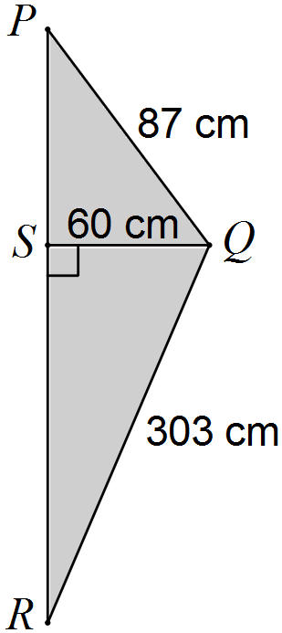

(a) If the metal pipe costs $15.50 per metre, determine the cost of the pipe used to make the frame. (3 marks)

(b) The cloth used to make the flag, shaded grey in the diagram, costs $45 per square metre. Determine the cost of the cloth required. (3 marks)

(c) If labour costs are 240% of total material costs, determine the total cost of the advertising flag. (2 marks)

Question 11 (9 marks)

A supermarket is offering the same brand of frozen peas for sale in three different sized packets: 1.5 kg for $10.25, 750 g for $5.83 or 250 g for $1.85.

(a) Rank the packet sizes from worst to best buy, justifying your ranking. (3 marks)

(b) The supermarket has limited stocks of the 500 g size of frozen peas and want to price these packets to be the worst buy of all four sizes. Calculate the minimum price they should charge for this size packet, to the nearest 10 cents. (2 marks)

(c) The supermarket is considering an offer to customers so that they can purchase four of the 250 g packets for the price of a 750 g packet. What percentage discount is this per packet? (2 marks)

(d) The prices include 10% GST. Determine

(i) the amount of GST included in the price of the 750 g packet. (1 mark)

(ii) the price of the 1.5 kg packet without GST. (1 mark)

Question 12 (7 marks)

Light vehicle licence fees in Western Australia are calculated using the formula shown below:

Fee $=$ Vehicle fee per 100kg $×$ Total weight (rounded up to the nearest 100kg) $÷$ 100 + $19.45.

The table below shows the light vehicle licence fees calculated using the above formula, in dollars, for a range of vehicle types and rounded up weights.

|  |  |  |  |  |  |  |  |
| --- | --- | --- | --- | --- | --- | --- | --- |
| Total weight (rounded up) | | 100 kg | 200 kg | 1000 kg | 1400 kg | 1500 kg | 1600 kg |
| Vehicle | Fee per 100kg |  |  |  |  |  |  |
| Motor car | $19.99 | 39.44 | 59.43 | 219.35 | 299.31 | 319.30 | A |
| Motorcycle | $39.98 | 59.43 | 99.41 | 419.25 | 579.17 | 619.15 | 659.13 |
| Caravan | $5.00 | 24.45 | 29.45 | B | 89.45 | 94.45 | 99.45 |

(a) Use the table to determine the licence fee for

(i) a motorcycle with a rounded up weight of 200 kg. (1 mark)

(ii) a motor car weighing 1 415 kg. (1 mark)

(b) Calculate the values of A and B in the table. (2 marks)

(c) Calculate how much cheaper it is to licence a 1 140 kg caravan than a 215 kg motorcycle in WA. (3 marks)

Question 13 (7 marks)

A company logo is shown below, formed by three concentric circles of radii 5, 10 and 15 cm that are divided up into four quadrants by two straight lines intersecting at right-angles.

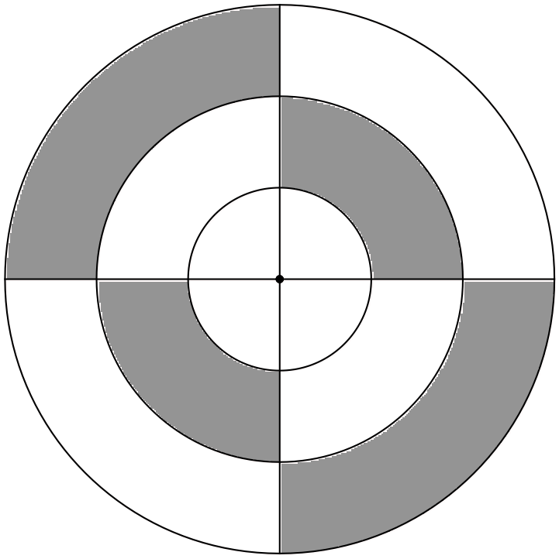

(a) A model of the logo is to be made, using thin wire for the circles and lines. Calculate the total length of wire needed. (3 marks)

(b) Calculate the total shaded area of the logo. (4 marks)

Question 14 (10 marks)

The Newstart Allowance is a government payment to help individuals aged 22 years or more who are looking for work. The maximum fortnightly payment for a single person with no children is $523.40.

Newstart Allowance recipients can earn up to $102 per fortnight before tax before their payment is affected. Income above $102 and up to $252 per fortnight reduces the fortnightly payment by 50 cents in the dollar and income above $252 per fortnight reduces the payment by 60 cents in the dollar.

(a) Determine the fortnightly Newstart Allowance paid to the following:

(i) a person who earns $120 per week. (3 marks)

(ii) a person who works part time in a job paying $22.75 per hour for 12 hours each week. (4 marks)

(b) Over what fortnightly amount will an individual, who qualifies for Newstart Allowance, no longer receive any payment? (3 marks)

Question 15 (9 marks)

Large steel washers used in the construction of bridges have an external radius of 9.5 cm, an internal radius of 3.5 cm and a thickness of 1.25 cm.

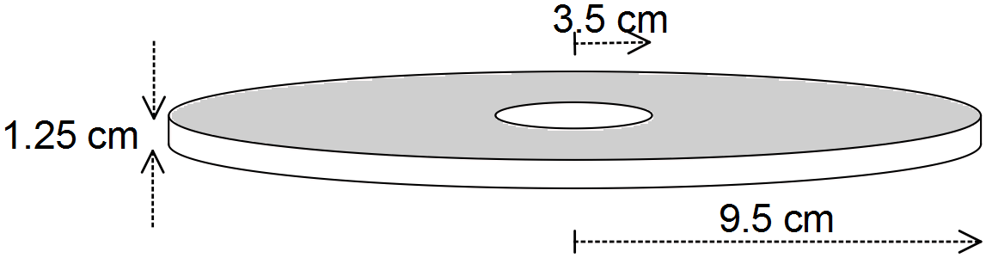

(a) Determine the volume of one washer. (3 marks)

(b) For transportation, the washers are packed into bins that can carry a maximum weight of 500 kg. If one cubic centimetre of steel used to make these washers weighs 7.7 grams, determine how many washers can be packed into one bin, to the nearest ten. (3 marks)

(c) The surface of the washer is coated with a rust-proofing agent. Determine the surface area of one washer. (3 marks)

Question 16 (8 marks)

(a) An investor bought 750 shares in a company for $12.75 each through an online broker that charged a brokerage fee of 0.35% on the value of the shares. The company forecast a dividend of 95 cents per share.

(i) Calculate the total cost of buying the shares. (3 marks)

(ii) Calculate the expected dividend for these 750 shares. (1 mark)

(b) Use the following information on two companies to determine which company has the lowest price-to-earnings ratio. (4 marks)

* Acorn: Annual earnings of $7.3 million, with a total of 8 million shares issued and a market price of $14.80 per share.
* Billet: A market price of $6.60 per share, with last dividend of 8.5c per share and 25% of the annual earnings paid as dividend.

Question 17 (10 marks)

Pyramid ABCDE has a square base of side 24 cm and four sloping edges of length 37 cm, as shown in the diagram below.

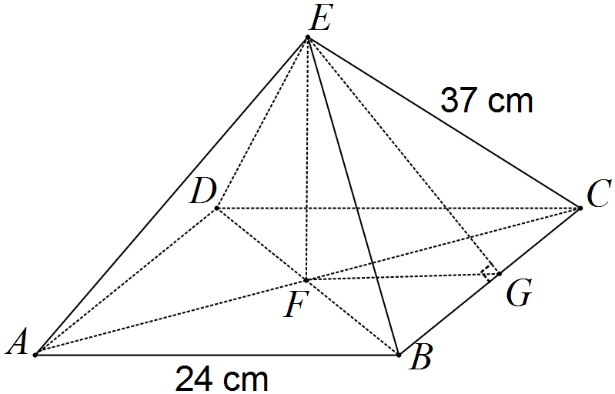

(a) Calculate the length of EG, where G is the midpoint of BC. (2 marks)

(b) Determine the area of triangle BCE. (1 mark)

(c) Determine the total surface area of all five faces of the pyramid. (2 marks)

(d) Calculate the length of FC, where F is the midpoint of AC. (2 marks)

(e) Show that the perpendicular height of the pyramid, EF, is 33 cm, to the nearest cm.

(1 mark)

(f) Calculate the volume of the pyramid. (2 marks)

Question 18 (8 marks)

The ticket sales for an amateur dramatic production are shown in the matrix T below for three nights of the show. Adult tickets cost $18 each and child tickets were $5 each.



(a) Represent the ticket prices in a suitable matrix P and then use matrix multiplication to calculate matrix S, the product of P and T. (2 marks)

(b) Explain what information matrix S shows. (1 mark)

(c) By how much did the income from the Saturday show exceed the Thursday performance?

(1 mark)

(d) Show how to multiply matrix S by another matrix to obtain a matrix that shows the total income over all three nights of the show. (2 marks)

(e) Some members of the society felt that in the future, children should attend for free and adult tickets should cost an extra $2.50 to make up the shortfall. Determine whether this increase would have made up the shortfall over these three nights. (2 marks)

Question 19 (9 marks)

The currency exchange rates in Australian dollars for four countries are shown in the table below.

|  |  |  |  |
| --- | --- | --- | --- |
| Country/Region | Currency | Buy | Sell |
| Germany | Euro | 0.7242 | 0.6371 |
| Japan | Yen | 94.46 | 80.80 |
| India | Rupee | 60.76 | 46.48 |
| South Africa | Rand | 13.32 | 11.17 |

(a) Explain why an Australian traveller going on holiday to South Africa would use the rate of 11.17 to estimate how many rand they will get when they convert their dollars. (1 mark)

(b) The midrate is the average of the buying and selling rates. Calculate the midrate for Indian rupees. (1 mark)

(c) A student was returning from Japan with 8 100 yen after a holiday. How much would they receive in Australian dollars? (1 mark)

(d) A traveller exchanged $5 000 into euros, but then cancelled their trip and converted their money back into Australian dollars. How much did they lose on these transactions?

(3 marks)

(e) Specialist software can be purchased online from a German company for 149 euros or from a Japanese company for 19 900 yen. Compare the costs in Australian dollars and hence calculate how much can be saved by buying from the cheapest company.

(3 marks)

Additional working space

Question number: _________

Additional working space

Question number: _________

Additional working space

Question number: _________

Additional working space

Question number: _________

© 2016 WA Exam Papers. Baldivis Secondary College has a non-exclusive licence to copy and communicate this paper for non-commercial, educational use within the school. No other copying, communication or use is permitted without the express written permission of WA Exam Papers.